AYURVEDIC HOME REMEDIES

1. **Digestive Issues** :
   * 1. Indigestion: Drink a cup of warm water with a teaspoon of cumin seeds and a pinch of black salt.

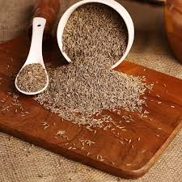

Fig(1) : cumin seed

* + 1. Constipation: Eat soaked prunes or figs, or drink a warm glass of water with a teaspoon of ghee before bed.

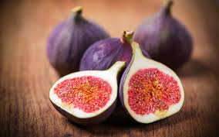 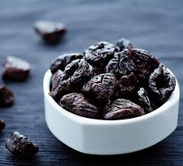

Fig(2) : prunes fig(3) : figs

* + 1. Acid Reflux: Sip on a tea made from fennel seeds or a mix of equal parts of dried ginger, cardamom, and cumin seeds.

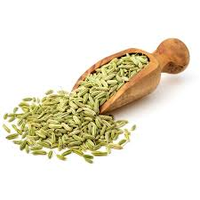 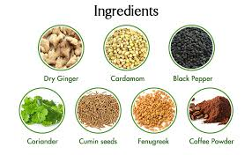

Fig(4): fennel seeds Fig(5): ginger, cardamom, and cumin seed

1. **Headaches:**
2. Migraines: Apply a paste of sandalwood powder and rose water to the forehead, or drink ginger tea.

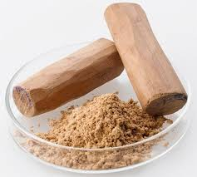 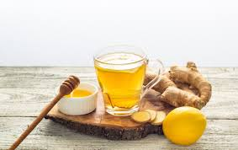

Fig(6): sandalwood powder Fig(7): ginger tea

ii) Tension Headaches: Massage the temples with a mixture of equal parts of coconut oil and peppermint oil.

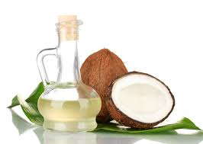 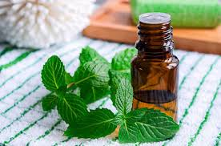

Fig(8) coconut oil Fig(9) peppermint oil

**3. Respiratory Problems:**

i) Cold and Cough: Boil a few basil leaves, ginger, and a pinch of black pepper in water. Drink this concoction with a teaspoon of honey.

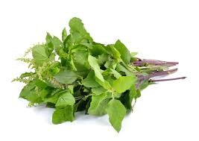 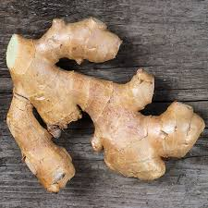

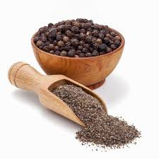 Fig(10): basil leaves Fig(11): ginger

Fig(12):black pepper

1. Sore Throat: Gargle with warm salt water or a mixture of turmeric powder and salt in warm water.

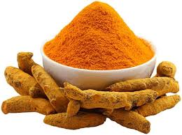

Fig(13): turmeric

1. **Skin Problems:**
2. Acne: Apply a paste of turmeric and sandalwood powder mixed with a little water on the affected areas.

 

Fig(14): turmeric Fig(15): sandalwood powder

ii) Dry Skin: Use a mixture of honey and mashed banana as a face mask. Leave it on for 15 minutes before washing off.

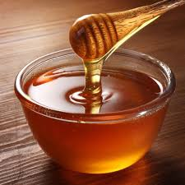 

Fig(16): Honey Fig(17): banana

**4. Hair Issues:**

i)Dandruff: Massage your scalp with warm coconut oil mixed with a few drops of lemon juice. Leave it overnight and wash it off the next morning.

 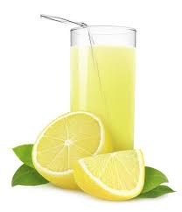

Fig(18): coconut oil Fig(19): lemon juice

ii) Hair Fall: Apply a paste of fenugreek seeds soaked overnight and ground into a paste on your scalp. Leave it for 30 minutes before washing off.

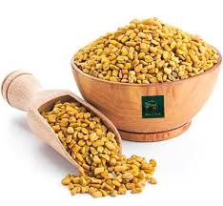

Fig(20): fenugreek seeds

**5. Joint Pain:**

i) Arthritis: Massage with warm sesame oil or mustard oil on the affected joints. You can also drink a glass of warm milk with a teaspoon of turmeric powder.

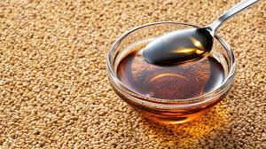

Fig(21): sesame oil

**6. Stress and Anxiety:**

**i)** Relaxation: Drink a cup of warm milk with a pinch of nutmeg before bedtime.

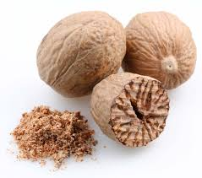

Fig(22): nutmeg

ii) Calming: Practice deep breathing exercises and meditation daily.

**7.** **General Health:**

i) Immunity Boost: Drink a mixture of warm water, lemon juice, and honey every morning.

 

Fig(23): lemon juice Fig(24): honey

ii)Detoxification: Start your day with a glass of warm water mixed with half a lemon juice.

**8. Sleep Problems:**

i)Insomnia: Drink a cup of warm milk with a pinch of nutmeg before bed.



Fig(25): nutmegs

**9. Eye Strain:**

i)Tired Eyes: Place cooled cucumber slices or cotton pads soaked in rose water on your eyes for 10-15 minutes.

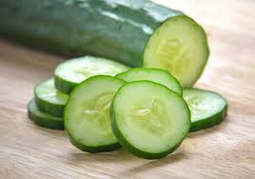

Fig(26): cucumber slices

**10.** **Menstrual Cramps:**

i) Pain Relief:Drink a warm infusion of ginger tea or a mixture of half a teaspoon of cinnamon in warm milk.

 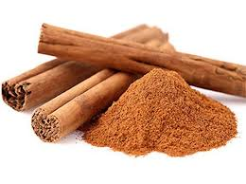

Fig(27): ginger tea Fig(28): cinnamon

**11. High Blood Pressure:**

i)Regulation: Drink a glass of warm water with a tablespoon of apple cider vinegar and a teaspoon of honey daily.



Fig(29): apple cider vineger

**12. Cold Feet and Hands:**

i) Circulation:Soak your feet in warm water with a pinch of salt and mustard powder for 15 minutes**.**

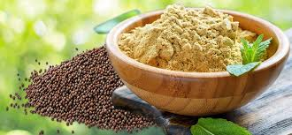

Fig(30): musturd powder